- NETWORK DIAGNOSTICS, MONITORING AND WIRESHARK ASSIGNMENT
Q1. IP Configuration Using ipconfig /all
- Press Windows + R, type cmd and press Enter.
- Type ipconfig /all and press Enter.
- Find your active Wi-Fi or Ethernet adapter.
- Identify IPv4 Address, Subnet Mask, Default Gateway and DNS Servers.
- Take a screenshot showing the relevant values.
ipconfig /all
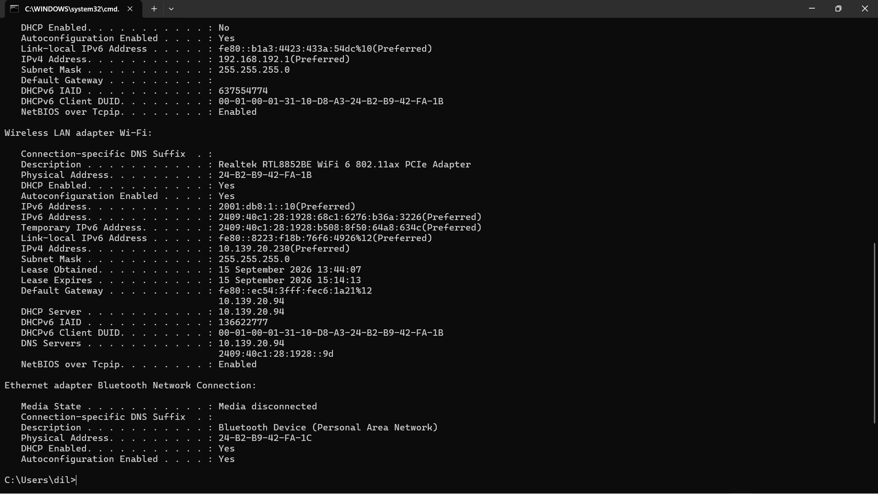
Q2. Ping Test With Network Disconnected and Connected
Disconnect Wi-Fi or Ethernet and run:
ping www.google.com

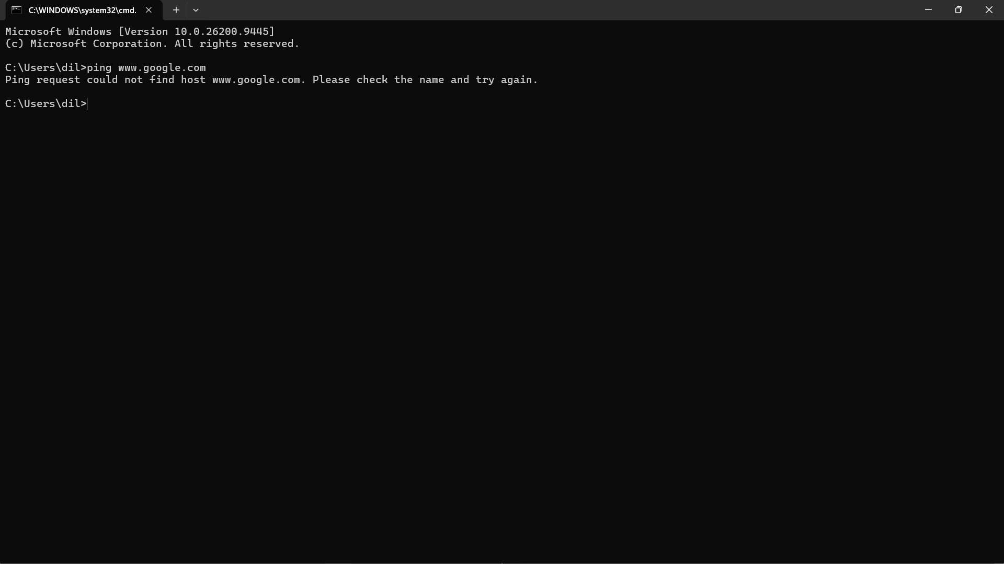
Reconnect to the network, wait for Internet access, and run the same command again:
ping www.google.com
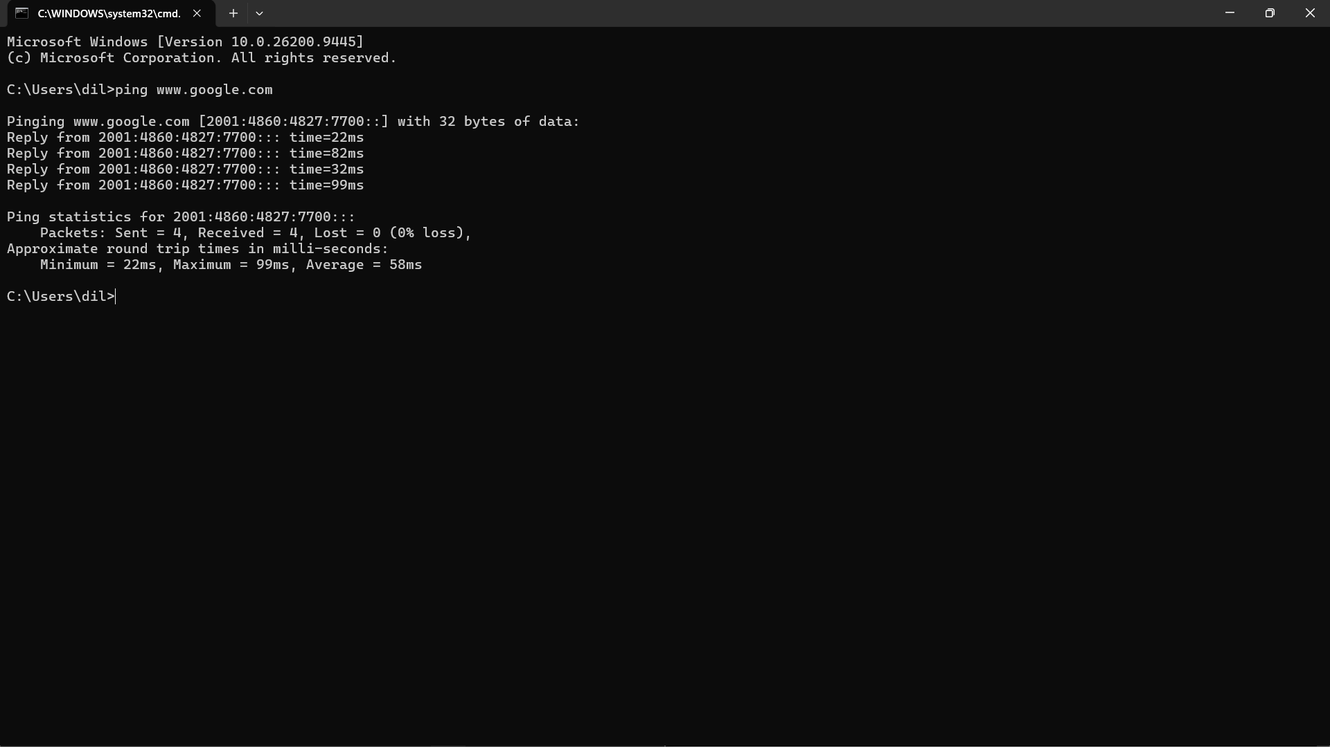
Short Note: When disconnected, ping normally fails because the computer has no usable network path or cannot resolve the name. After reconnection, successful Reply lines indicate connectivity. The time in ms is the round-trip delay.
Q3. Monitor Network Usage While Streaming YouTube
- Press Ctrl + Shift + Esc to open Task Manager.
- Open Processes and make sure the Network column is visible.
- Open YouTube in your browser and stream a video.
- Watch the Network column for about 5 minutes.
- Record the highest value you observe and the process using the most bandwidth.
- Take a screenshot showing the process and Network column.
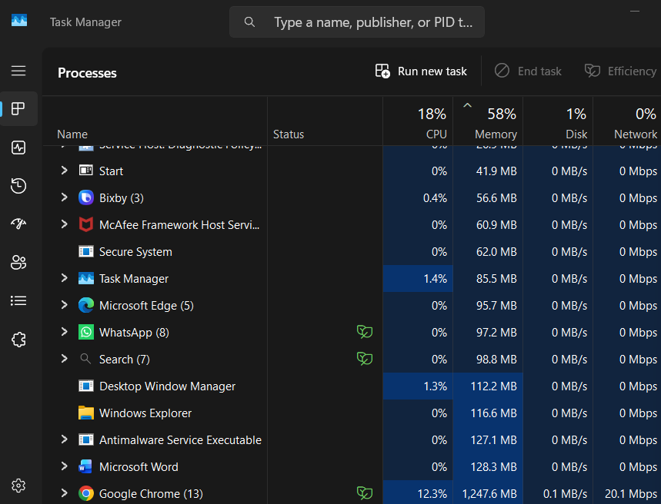
Q4. Capture and Filter Web Traffic in Wireshark
- Open Wireshark and double-click your active Wi-Fi/Ethernet interface.
- Browse Flipkart or Instagram Web for at least 30 seconds.
- Return to Wireshark and click the red Stop button.
- Use the display-filter bar. Try http for unencrypted HTTP traffic.
- Because modern sites normally use HTTPS, use tls for TLS traffic or tcp.port == 443 for TCP traffic on HTTPS port 443. HTTP/3 traffic may use QUIC/UDP.
- Take a screenshot showing the filter and filtered packets.
http
tls
tcp.port == 443
Three types of information visible in packet metadata:
- Source and destination IP addresses.
- Source/destination ports and transport protocol.
- Packet length, timing and protocol/TLS handshake metadata.
Note: A blank http filter does not necessarily mean the capture failed because Flipkart and Instagram normally use encrypted HTTPS.
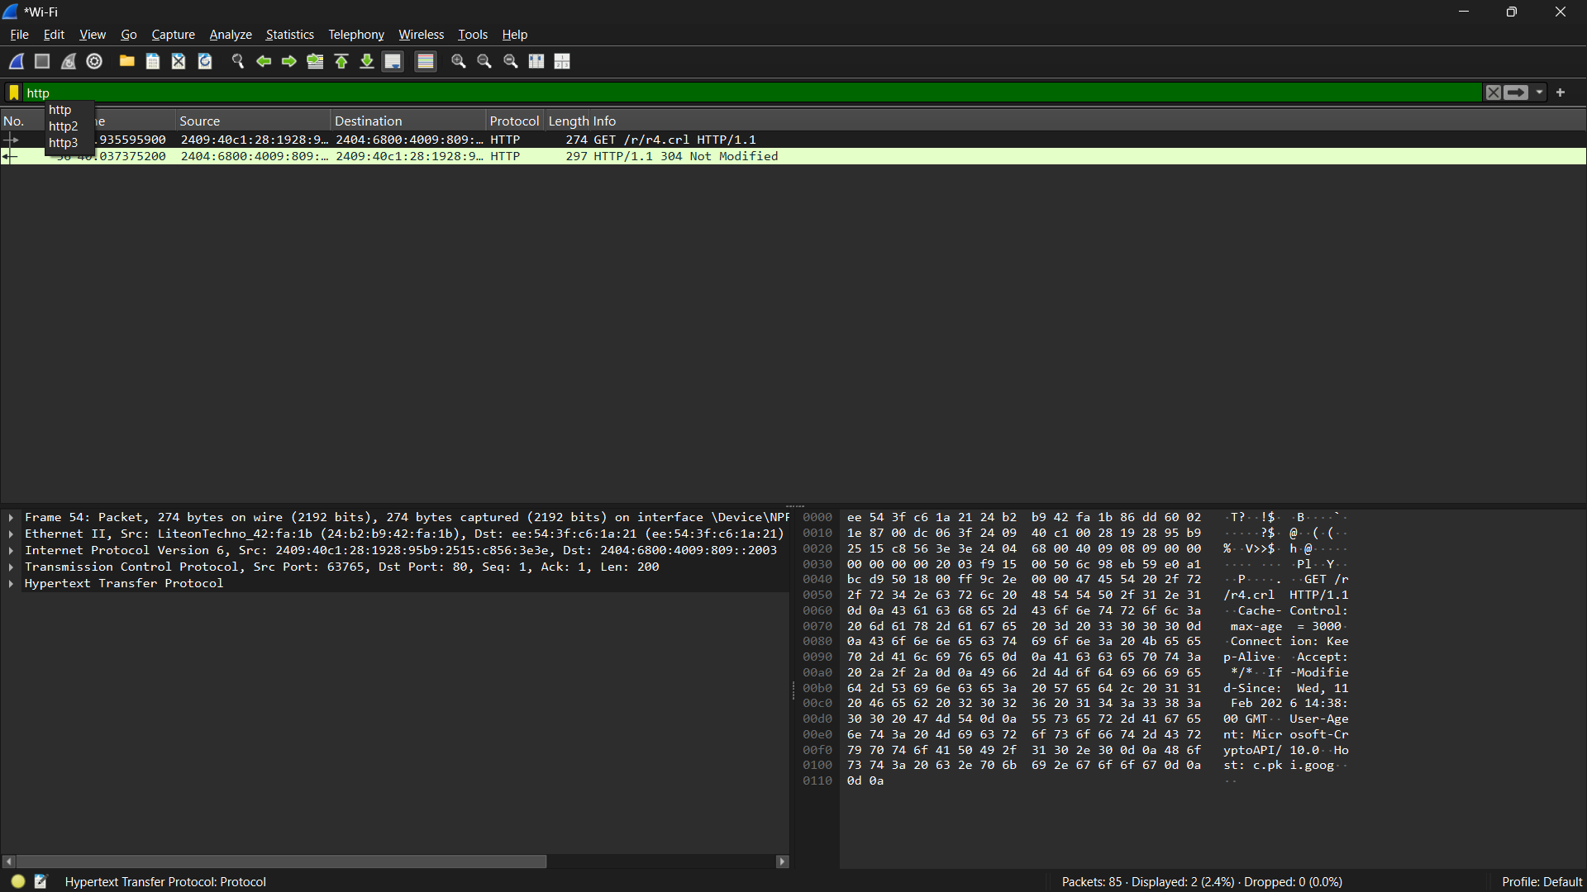
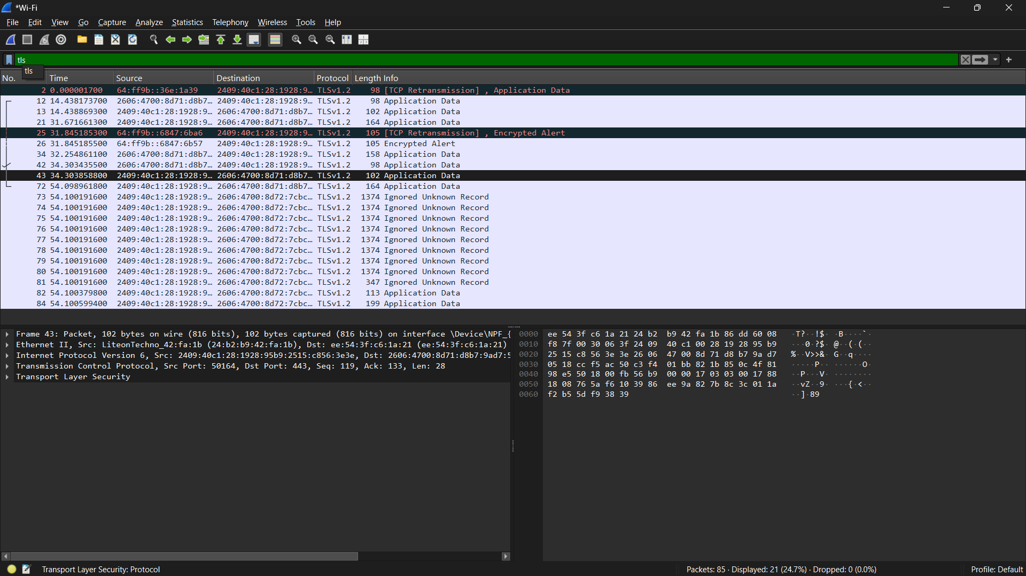

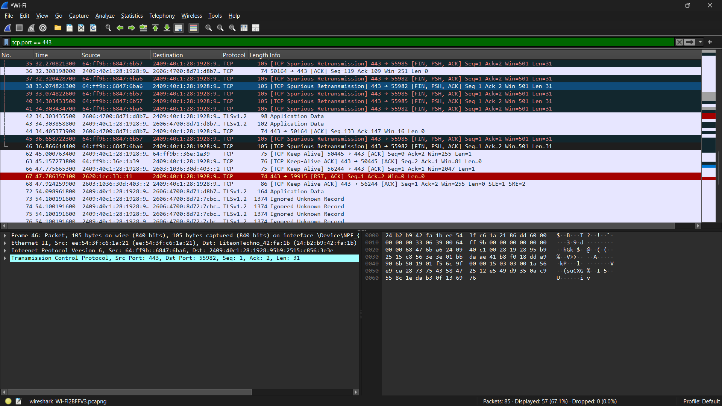

Q5. AI Troubleshooting Checklist for Slow Online Gaming
- Run a speed test and check ping/latency and packet loss.
- Use a wired Ethernet connection when possible, or move closer to the Wi-Fi router. ← Suggestion I would try first
- Pause large downloads, cloud backups and heavy streaming on other devices.
- Restart the router/modem and gaming device.
- Update router firmware and network adapter drivers.
- Use a less congested Wi-Fi band/channel where supported.
- Contact the ISP if poor speed, high latency or packet loss continues on multiple devices.
I would try Ethernet first because a wired connection is usually more stable and avoids many Wi-Fi interference problems.
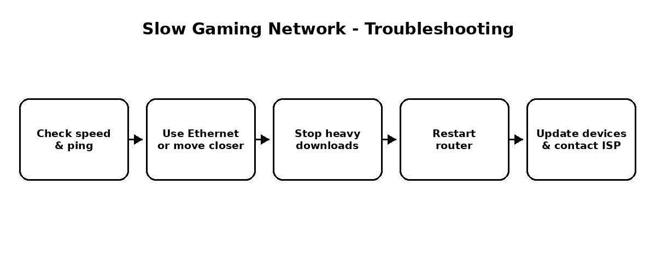

Conclusion
These activities use Windows and Wireshark tools to check IP configuration, connectivity, bandwidth usage and packet metadata, providing a practical introduction to network troubleshooting.

